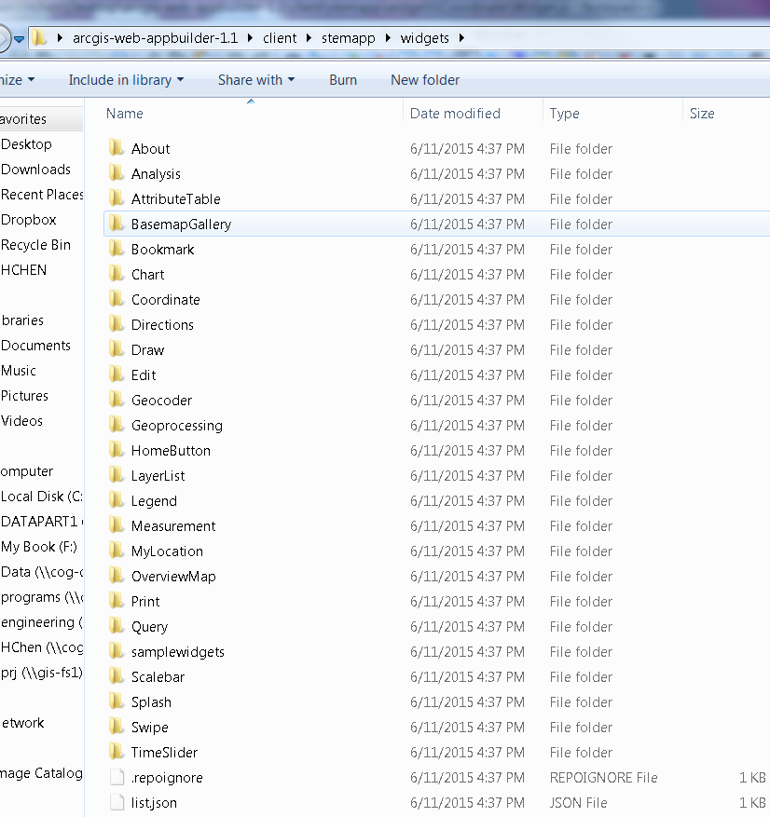

<http://mis-lt-bgwh6p1.cog.coggov.local:3344/webappbuilder/?id=stemapp>

